Activity No 4.Finance Club Event “The Finance Alphabet Chain”

Title of the Event | Finance Club Event “The Finance Alphabet Chain” | 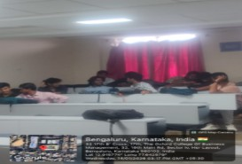
Day and Date | 14.01.26
Venue (With all details ) | Roon No-309
In collaboration with ( if any) | -
Details of Resource Person With Designation | Asst.Prof. Ritu U | 
Organizing Department/Coordinators | Business Management . Asst.Prof. Ritu U
Course and semester | MBA I Semester
No of Students & Faculty Participants | 32

Coordinator HoD Vice-Principal Principal

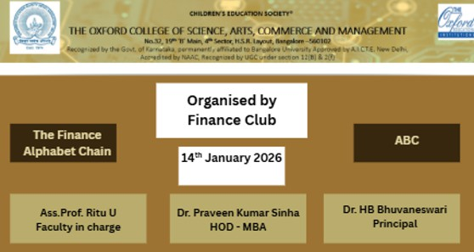

Introduction
On 14th January 2026, the Finance Club organized a fun and interactive vocabulary-building activity for students. The primary objective was to break the stereotype of finance being "boring" and to introduce complex financial terminology through a gamified format. Inspired by the traditional game of Antakshari, the activity challenged students to think on their feet and recall financial terms in alphabetical order.

Description of the Activity

The activity was designed as a competitive "Word Chain" game. Students were divided into teams, and the following rules were applied. The Alphabetical format Each participant had to provide a finance-related word starting with the letter that followed the previous word (A, B, C...) or, in the Antakshari variation, starting with the last letter of the previous team's word. Time constraint Each student/team had only 10 seconds to respond to maintain a high-energy atmosphere.

Outcome of the Activity
The session resulted in several positive learning outcomes. Vocabulary Expansion: Students collectively identified over 50 unique financial terms, many of which were new to the junior participants. Quick Thinking: The fast-paced nature of the game improved the students' mental agility and recall of technical concepts. Peer-to-Peer Learning: When a difficult word was mentioned, it sparked immediate curiosity, leading to brief, student-led explanations.

Conclusion
The session resulted in several positive learning outcomes: Vocabulary Expansion: Students collectively identified over 50 unique financial terms, many of which were new to the junior participants. Quick Thinking: The fast-paced nature of the game improved the students' mental agility and recall of technical concepts. Peer-to-Peer Learning: When a difficult word was mentioned, it sparked immediate curiosity, leading to brief, student-led explanations

